**4.spring-rest-handson-outputs**

**Create RESTful Web Service to handle POST request of Country**

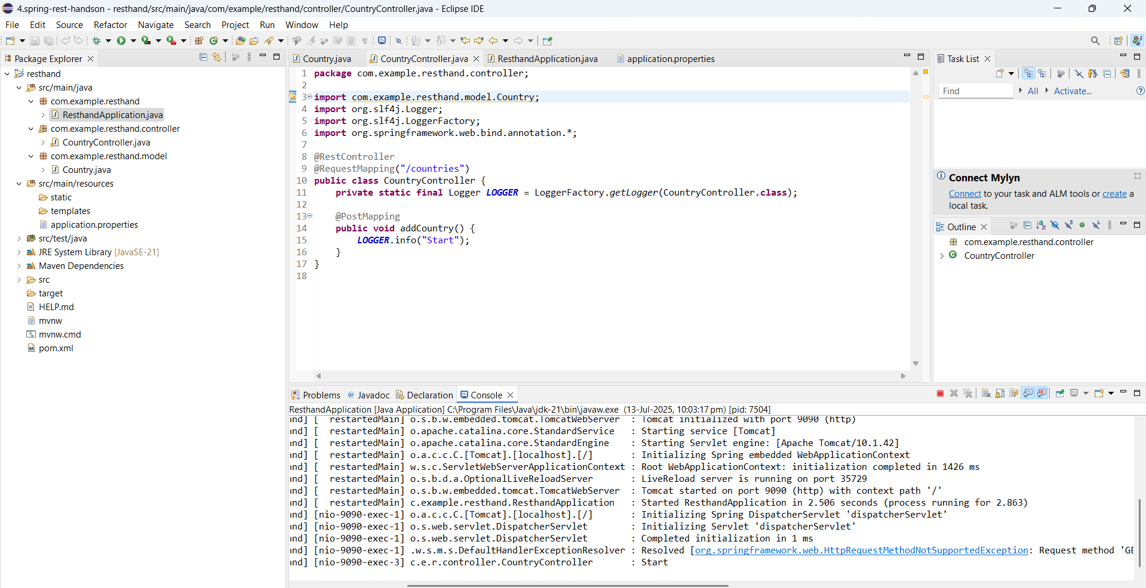

**Read country data as a bean in RESTful Web Service**

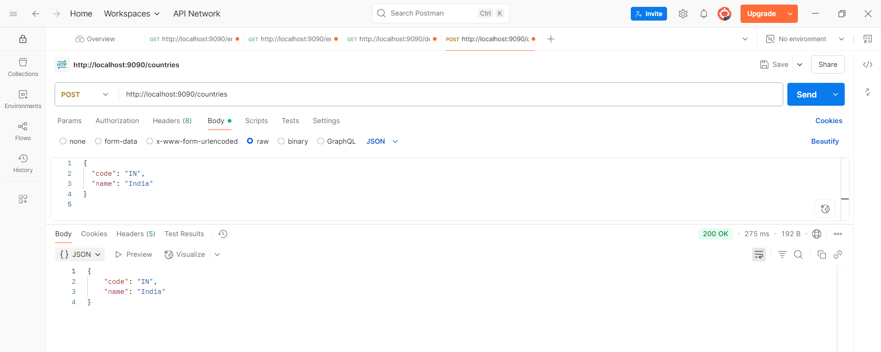

**Validating country code**

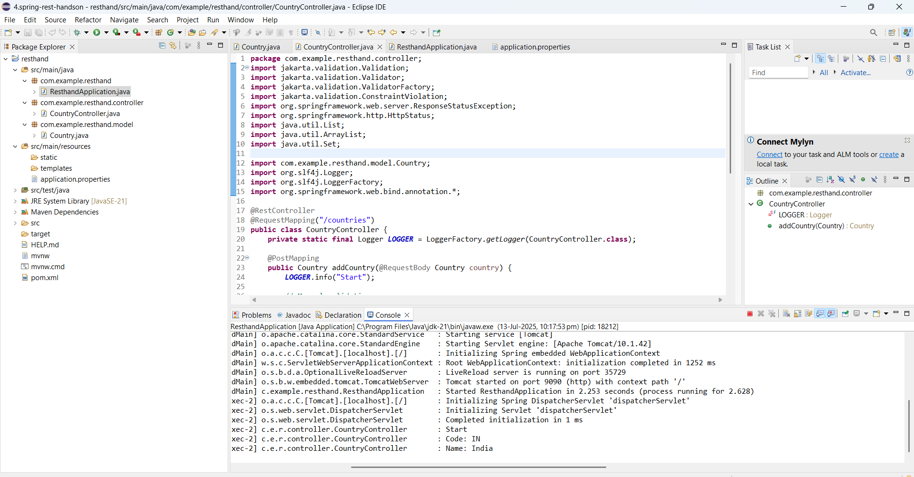

**Global Exception Handler for Validation**

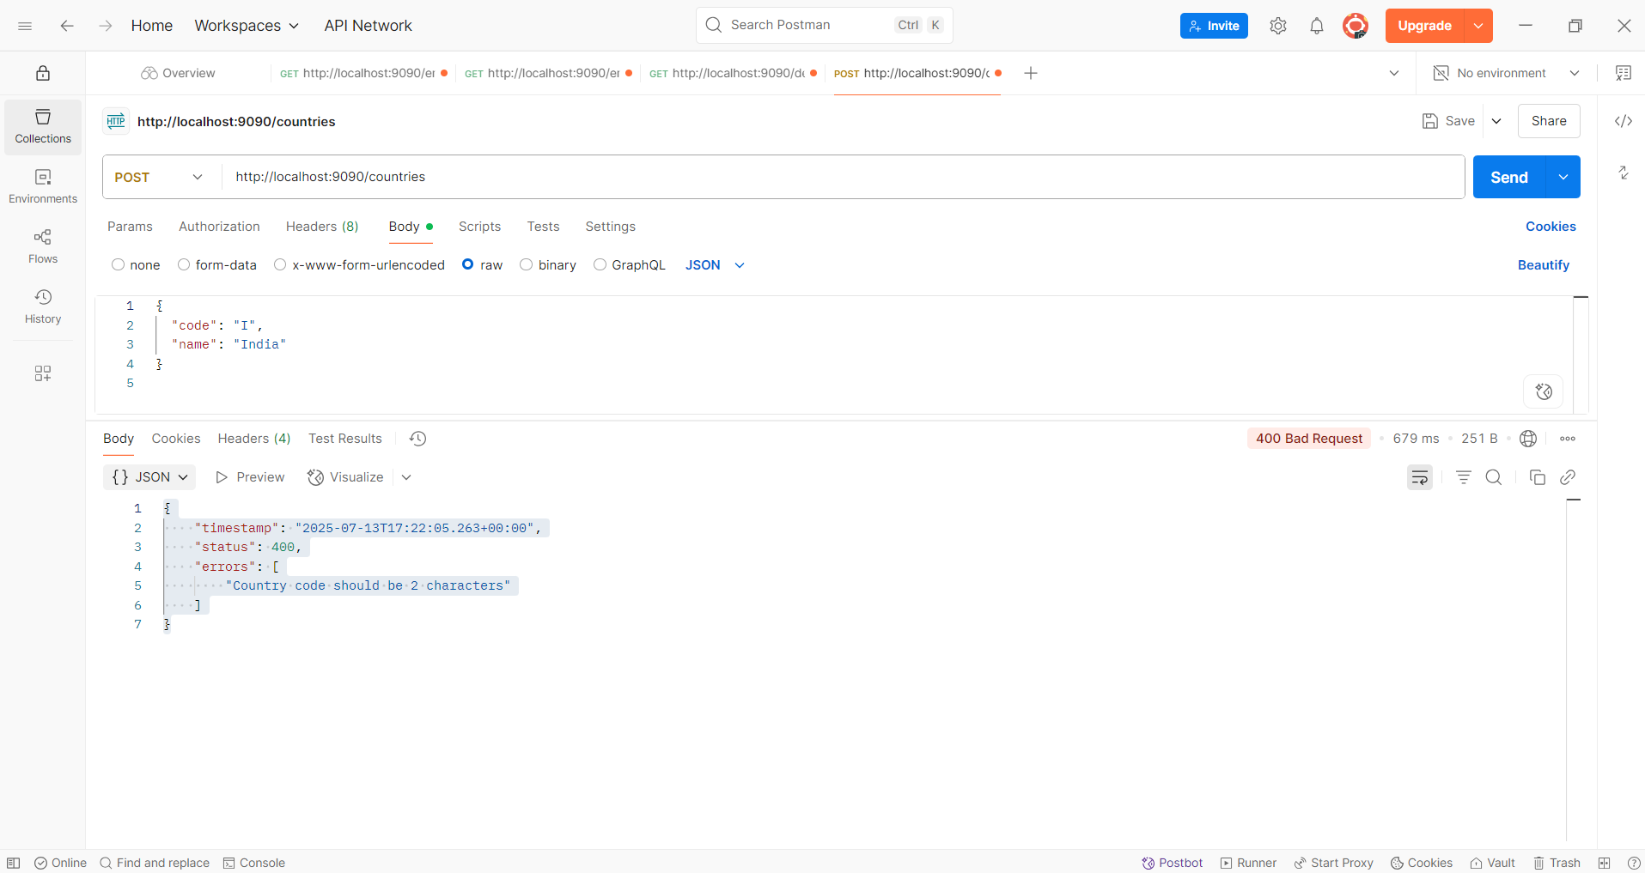

**Implement REST service for updating an employee**

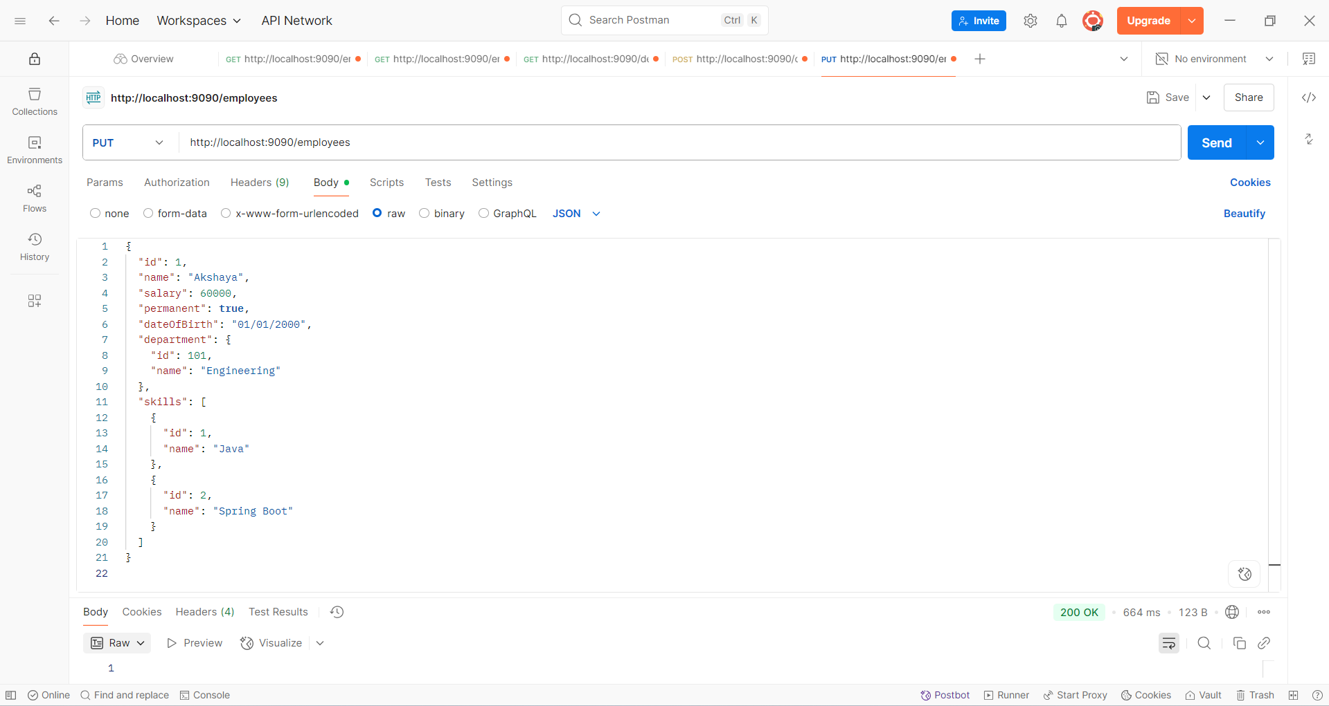

**Implement REST DELETE Service**

